**Software Requirements Specification (SRS)**

**Project Title: ZaraiLink**

#### In Collaboration with Pakistan Agriculture Research

**Kaavish Project**

### Fall 2025

##### Team Members:

Umar Kashif (Project Lead)

Syed Fahad Nadeem (Machine Learning Specialist, Front-end Developer) Salman Adnan (Data Specialist, Contact Person)

Ibrahim Rana (Mobile App Developer, Documentation Manager)

DSSE

Habib University Karachi Campus

November 12, 2025

**Contents**

1. Introduction 2
   1. Purpose . . . . . . . . . . . . . . . . . . . . . . . . . . . . . . . . . . . . 2
   2. Scope . . . . . . . . . . . . . . . . . . . . . . . . . . . . . . . . . . . . . 2
2. Project Plan 3
   1. Project Objectives . . . . . . . . . . . . . . . . . . . . . . . . . . . . . . 3
   2. Tasks . . . . . . . . . . . . . . . . . . . . . . . . . . . . . . . . . . . . . . 3
   3. Project Timeline . . . . . . . . . . . . . . . . . . . . . . . . . . . . . . . 5
   4. Resources . . . . . . . . . . . . . . . . . . . . . . . . . . . . . . . . . . . 5
   5. Task Division . . . . . . . . . . . . . . . . . . . . . . . . . . . . . . . . . 6
   6. Functional Requirements . . . . . . . . . . . . . . . . . . . . . . . . . . . 7
      1. User Authentication & Management . . . . . . . . . . . . . . . . 7
      2. User Dashboard & Personalization . . . . . . . . . . . . . . . . . 7
      3. Trade Directory . . . . . . . . . . . . . . . . . . . . . . . . . . . . 7
      4. TradeLens – Market Intelligence . . . . . . . . . . . . . . . . . . . 7
      5. TradePulse – Alerts & Market Events . . . . . . . . . . . . . . . . 7
      6. TradeLedger – Company Analytics . . . . . . . . . . . . . . . . . 8
      7. AI Chatbot Assistant . . . . . . . . . . . . . . . . . . . . . . . . . 8
      8. Notifications & Recommendations . . . . . . . . . . . . . . . . . . 8
      9. Use Case Diagram . . . . . . . . . . . . . . . . . . . . . . . . . . 8
   7. Non-Functional Requirements . . . . . . . . . . . . . . . . . . . . . . . . 8
      1. Performance . . . . . . . . . . . . . . . . . . . . . . . . . . . . . . 8
      2. Scalability . . . . . . . . . . . . . . . . . . . . . . . . . . . . . . . 9
      3. Reliability & Availability . . . . . . . . . . . . . . . . . . . . . . . 9
      4. Security & Data Governance . . . . . . . . . . . . . . . . . . . . . 9
      5. Usability & Accessibility . . . . . . . . . . . . . . . . . . . . . . . 9
      6. Data Integrity & Backup . . . . . . . . . . . . . . . . . . . . . . . 9
      7. Deployment & Integration 10
3. System Diagram 11
   1. Overview 11
   2. Wireframes Overview 13

**Chapter 1 Introduction**

# Purpose

The purpose of this document is to outline the Software Requirements Specification (SRS) for the **ZaraiLink Project**. It provides an overview of the functional and non-functional requirements, use cases, datasets, and system architecture for developing a comprehensive agricultural intelligence platform built on PAR data. ZaraiLink enables users to explore agricultural trade and market dynamics by allowing them to: discover new trade op- portunities, benchmark product prices and performance, monitor market shifts through alerts, evaluate competitors and partners, and plan smarter trade decisions across crops and regions.

# Scope

The scope of this project is to develop Zarailink, an AI-driven agricultural trade intel- ligence platform designed to strengthen data-driven decision-making within Pakistan’s agri-business ecosystem. The platform aims to bridge existing information gaps by inte- grating verified customs and trade data provided by the Pakistan Agriculture Research (PAR), enabling users to access actionable insights on exports, imports, and domes- tic market trends. Through its modular design, Zarailink will allow users to analyze product-level intelligence, monitor market dynamics, and benchmark company perfor- mance across the agricultural supply chain. The platform will incorporate Graph Neural Networks (GNNs) to uncover hidden trade relationships, detect anomalies, and generate intelligent buyer–supplier recommendations. In addition to market analytics, Zarailink will feature a verified Trade Directory that allows users to connect with key decision- makers of registered companies, facilitating credible and transparent business networking. An integrated AI chatbot assistant will provide conversational access to market insights, while the overall system will prioritize an intuitive, user-friendly interface for practical, business-oriented intelligence. Ultimately, Zarailink seeks to empower Pakistani agricul- tural stakeholders to make faster, smarter, and more profitable trade decisions

**Chapter 2 Project Plan**

# Project Objectives

* Develop a unified agri-trade intelligence web platform that centralizes commod- ity data, trade networks, and real-time market insights for Pakistan’s agricultural sector.
* Implement four core analytical modules: **TradeLens**, **Trade Directory**, **Trade Ledger**, and **Trade Pulse**, to provide commodity-level analytics, verified B2B connections, company-level trade intelligence, and real-time alerts respectively.
* Integrate an **AI-powered chatbot assistant** that allows users to query trade data in natural language and receive contextual responses, visual summaries, and partner recommendations using Graph Neural Network (GNN) models.
* Deliver interactive Power BI–based dashboards and visualizations supporting multi- currency analytics (USD/PKR) and dynamic filtering across modules.
* Ensure a scalable backend architecture with RESTful APIs, responsive frontend design, and modular data integration for future expansion.
* Enable businesses to make data-driven decisions through actionable market intelli- gence, analytics, and performance insights.
* Collaborate with **PAR (Pakistan Agricultural Research)** to integrate ZaraiLink into their existing analytics ecosystem for wider adoption and long-term impact.

# Tasks

##### Data Collection and Integration

* + Gather commodity-wise data for multiple crops using PAR-provided Excel templates and import–export customs records.
  + Map the complete supply chain for each crop (excluding farmers) and identify all involved stakeholders such as processors, traders, exporters, and logistics providers.
  + Verify and record company contact information and trade roles in the official PAR directory format.
  + Compile and integrate all datasets into a unified data repository for further processing.

##### Data Cleaning and Standardization

* + Identify and handle duplicate, inconsistent, or incomplete entries across com- pany and transaction datasets.
  + Standardize all data attributes including company names, product categories, quantity units, and currency values.
  + Validate directory and transaction data against official trade sources to ensure reliability.
  + Prepare structured, analysis-ready datasets for system modules and database upload.

##### TradeLens Module Development

* + Design and develop the core analytics module for commodity-level insights using customs import–export data.
  + Implement dashboards showing KPIs such as trade volume, average price, top buyers/sellers, and country-wise shares.
  + Integrate dynamic filters for year, month, country, and commodity selection.
  + Store transaction and flow relationships within a graph-based knowledge net- work to support future recommendation and pattern discovery.
  + Ensure scalability to accommodate continuous weekly data updates.

##### Trade Ledger Module Development

* + Build company-level analytical dashboards summarizing trade activity, key partners, and performance trends.
  + Implement comparison features that allow users to analyze multiple companies side by side.
  + Visualize partner networks and trade flows to highlight diversification and market dependencies.

##### Trade Directory Module Development

* + Develop a verified directory for suppliers, buyers, and intermediaries catego- rized by product and region.
  + Implement advanced search and filtering for quick discovery of relevant com- panies.
  + Add company profile pages including overview details, contact information, and trade roles.
  + Support a token-based access system for unlocking key contacts.

##### Trade Pulse (News and Alerts)

* + Develop a real-time intelligence feed by scraping verified agricultural and trade news sources.
  + Categorize alerts by product, country, and type (price, policy, volume, or risk).
  + Display insights in a unified feed featuring trending topics, recent alerts, and followed commodities.
  + Generate detailed analysis pages with summaries, explanations, and visual data snapshots.

##### Graph Neural Network (GNN) Integration

* + Construct a graph-based representation of Pakistan’s agricultural trade net- work linking companies, products, and trade flows.
  + Train GNN models to identify patterns and suggest relevant partners or emerg- ing market opportunities.
  + Integrate GNN outputs into the TradeLens module and AI Chatbot for con- textual recommendations.

##### AI Chatbot Assistant

* + Develop a conversational AI interface enabling users to query the system in natural language.
  + Implement query handling for trade analytics, company lookup, and partner recommendations.
  + Fetch and summarize results dynamically from the TradeLens, Ledger, and Directory databases.
  + Present responses with short text summaries, visual previews, and direct dash- board links.

##### Frontend Development

* + Design and implement the web interface using a modern framework such as React.js.
  + Ensure responsive and user-friendly dashboards, feeds, and search layouts.
  + Integrate charting and visualization libraries for clear data representation.
  + Maintain design consistency across modules and optimize for performance.

##### Backend and APIs

* + Build a backend using Python and FastAPI to manage analytics, user inter- actions, and data communication.
  + Use PostgreSQL for structured relational data and Neo4j for graph-based GNN storage.
  + Develop RESTful APIs for frontend, chatbot, and analytics module integra- tion.
  + Implement secure authentication and access control mechanisms.

##### Deployment and Cloud Setup

* + Containerize the complete system using Docker for smooth deployment.
  + Host on AWS cloud for scalability, availability, and data security.
  + Automate regular updates, backups, and performance monitoring pipelines.

##### Testing and Documentation

* + Conduct unit and integration testing for all system components and APIs.
  + Validate data accuracy and model outputs across the TradeLens and Ledger modules.
  + Perform usability testing for the Trade Directory and Chatbot interfaces.
  + Prepare technical documentation, user manuals, and data source references.

# Project Timeline

The following Gantt chart outlines project milestones.

# Resources

* **Software Libraries:** We will be using Python-based libraries such as Pandas and NumPy for data cleaning and preprocessing, and Plotly for dashboard visualiza-

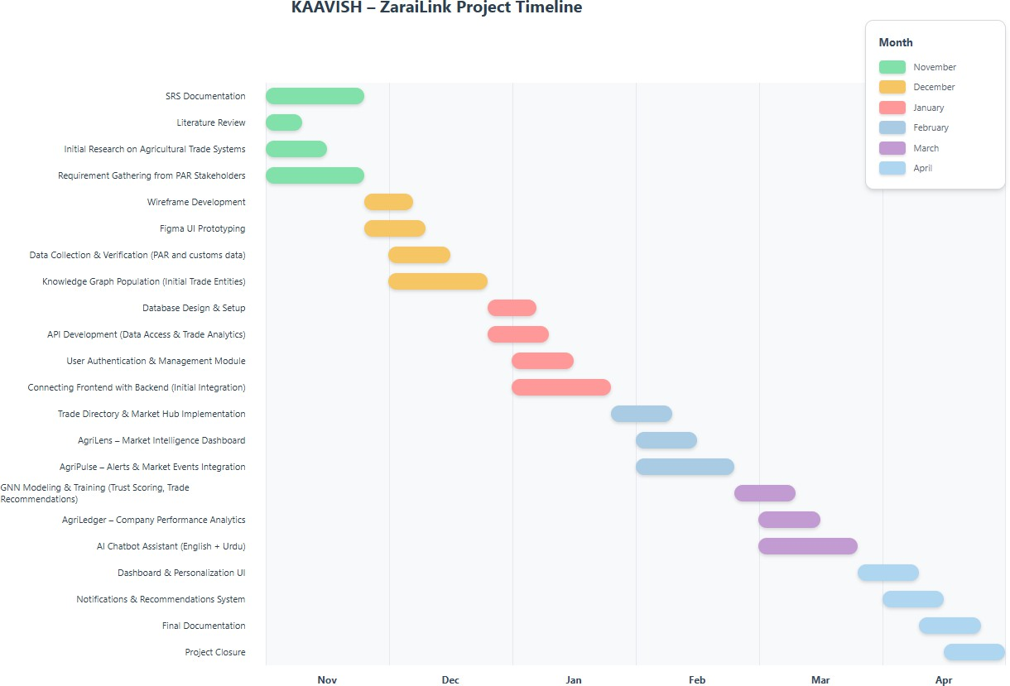

Figure 2.1: Project Gantt Chart

tions. FastAPI will be used for backend development, while React will handle the frontend interface. Neo4j will be used for graph-based data storage and GNN ex- perimentation, and PostgreSQL for relational data management. BeautifulSoup and Requests will support data scraping for the Trade Pulse module. For the AI Chatbot, we will use libraries such as Hugging Face Transformers, PyTorch, and NLTK for natural language processing and query understanding.

* **Hardware:** Development will primarily take place on local machines with standard CPUs and 8GB+ RAM. For computationally intensive tasks such as AI model training and graph processing, we will utilize GPU-enabled platforms like Google Colab or AWS EC2 instances. Deployment and testing will use Docker containers hosted on AWS or Render servers to ensure reliability and scalability.
* **Datasets:** The system will utilize PAR-provided Excel templates, verified com- pany directories, and import–export customs data for trade analysis. Additional trade-related information will be gathered from open data sources, verified com- pany websites, and scraped agricultural news articles. The AI Chatbot will use these datasets along with pre-trained language models for answering user queries.

# Task Division

* **Syed Fahad Nadeem** – GNN integration, AI Chatbot, Frontend dashboards.
* **Salman Adnan** – Data collection, cleaning, Trade Directory.
* **Umar Kashif** – Backend, API integration, database management.
* **Ibrahim Rana** – TradePulse module, documentation, UI/UX support.

# Functional Requirements

## User Authentication & Management

* + - * Users can sign up, log in, and manage their profile securely.
      * The system validates credentials and encrypts passwords.
      * Users can update organization details and reset credentials.

## User Dashboard & Personalization

* + - * A personalized dashboard provides access to TradeLens, TradePulse, TradeLedger, and the Trade Directory.
      * Displays saved searches, bookmarked companies, and recent analytics.
      * Interface adjusts content dynamically based on user behavior (importer/exporter patterns).

## Trade Directory

* + - * Acts as a verified agricultural business directory sourced from PAR.
      * Users can:
        + Search by product, HS code, or region.
        + View verified company profiles with trade data and contact information.
        + Bookmark preferred companies or markets.
      * Integrates with TradeLens, TradePulse, and TradeLedger for consistent data access.

## TradeLens – Market Intelligence

* + - * Displays export and import market insights for different commodities.
      * Provides interactive visualizations showing export volumes, top destinations, and price trends.
      * Generates customized analytical reports based on PAR’s dashboards.
      * Allows data export in PDF and Excel formats.

## TradePulse – Alerts & Market Events

* + - * Continuously monitors trade and pricing data for significant changes.
      * Uses Graph Neural Networks (GNNs) to detect anomalies in trade flows or com- modity prices.
      * Users receive notifications for:
        + Sudden price spikes or drops.
        + Policy changes or export restrictions.
        + Market disruptions affecting supply or demand.
      * Displays categorized alerts (high, medium, low) on the dashboard.

## TradeLedger – Company Analytics

* + - * Shows verified company transaction data, including partner companies and ex- port/import relationships.
      * Visualizes trade volumes, frequency, and trading partners.
      * Integrates with TradePulse to show how company transactions are impacted by market changes.

## AI Chatbot Assistant

* + - * Users can query the system using natural language.
      * Chatbot retrieves insights from trade databases and GNN-based models.
      * Supports queries such as:
        + “Show sugar export trends in 2024.”
        + “Which companies are importing wheat in Karachi?”
      * Responds with text summaries and visual previews.

## Notifications & Recommendations

* + - * The system delivers notifications for alerts, recommendations, and new data up- dates.
      * GNN-based recommendation engine suggests:
        + Potential trading partners.
        + Profitable export destinations.
        + Product-specific market opportunities.

## Use Case Diagram

The following diagram represents exporter interactions with the system.

# Non-Functional Requirements

## Performance

* + - * Dashboard and data queries load within 2–3 seconds.
      * GNN-based recommendations are generated within 5 seconds.

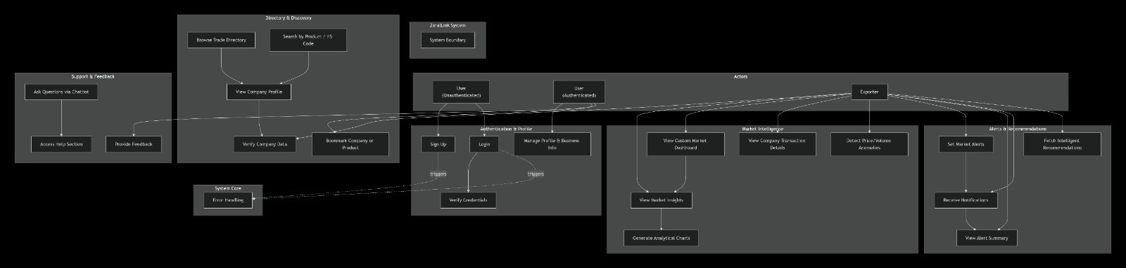

Figure 2.2: Use Case Diagram – Exporter Perspective

## Scalability

* + - * Supports over 15,000 concurrent users.
      * System scales horizontally with expanding PAR datasets.

## Reliability & Availability

* + - * Ensures 99.9% uptime through cloud infrastructure.
      * Includes automatic daily backups and failover recovery.

## Security & Data Governance

* + - * Uses HTTPS/TLS encryption for all data transfers.
      * Role-based access to verified company data.
      * Follows GDPR and Pakistan’s data protection laws.
      * Logs all system and trade interactions for auditing.

## Usability & Accessibility

* + - * Simplified interface for exporters and importers.
      * Supports Urdu and English.
      * Accessible via web and mobile devices.

## Data Integrity & Backup

* + - * All data validated before being added to the system.
      * Daily incremental and weekly full database backups.
      * Backup restoration verified through automated scripts.

## Deployment & Integration

* + - * Cloud-native deployment (AWS/Azure).
      * Continuous integration for feature updates.
      * Modular architecture for easy future expansion.

**Chapter 3 System Diagram**

# Overview

This section provides a high-level architecture showing interactions between users, databases, and machine learning models.

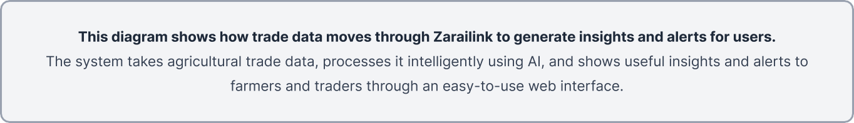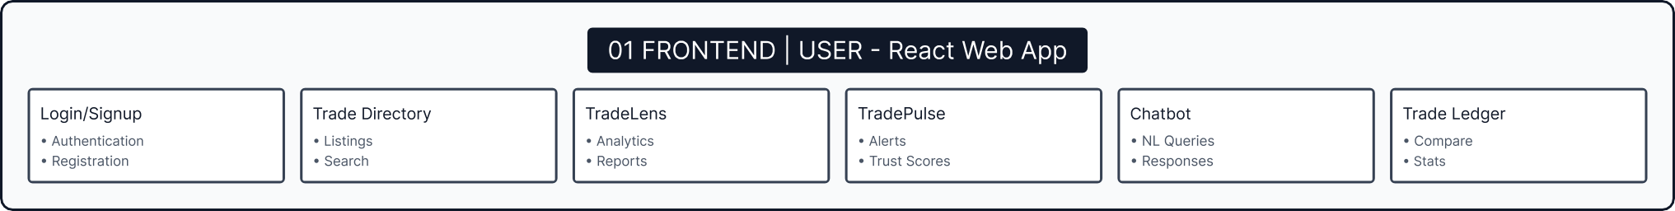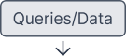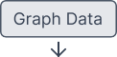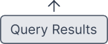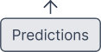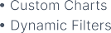

# Wireframes Overview

This section shows the user interface wireframes for ZaraiLink modules in their intended user flow.

ZaraiLink Wireframes

**Authentication**



@ Ask ZaraiBot



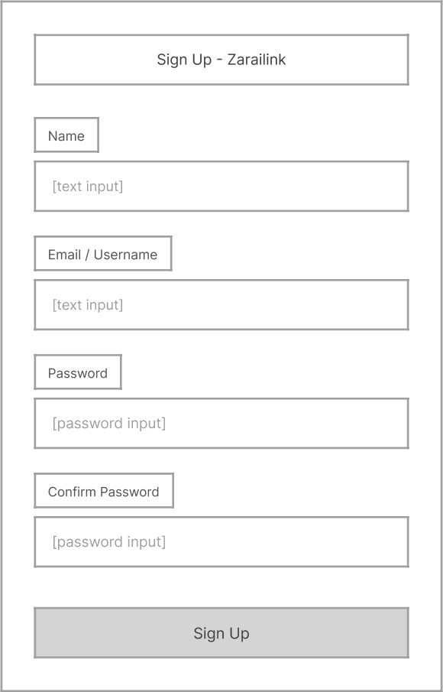





About

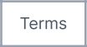

Terms



PAR Partnership

O

O

O



    





  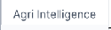



Home



Agri Insights



About



Sign In / Register







A bout



Terms



PAR Partnershïp



Ask ZaraiBot

**ZaraiLink Dashboard & TradeLens**

6

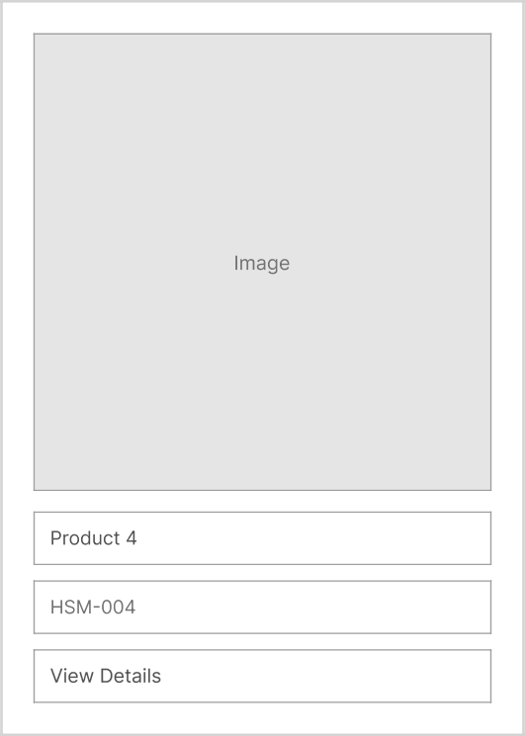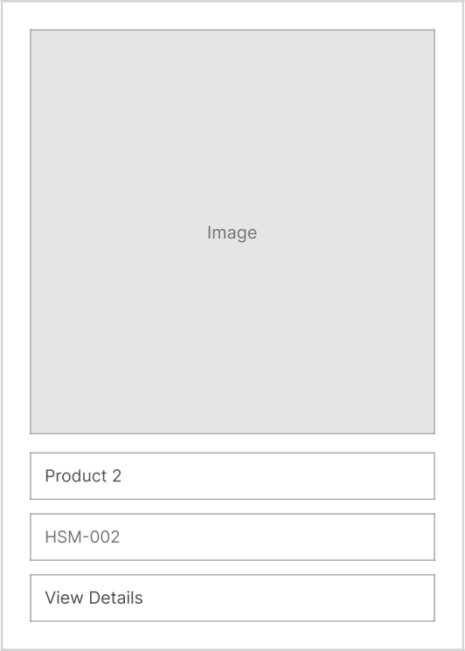



   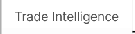 

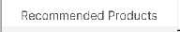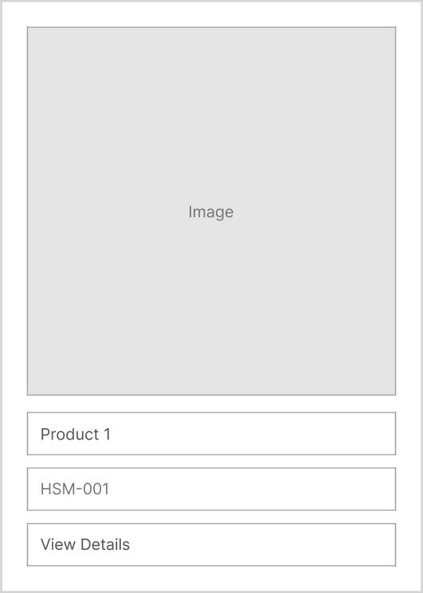

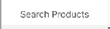

Search Products

SeõshbyHSMcodeorpoduúname...







About



Contact



Terms



PAR Partnership



Fahad Nadeem

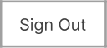

Sign Out



HS Code: 1201.90 | Category: Oilseeds | Unit: Metric Tons (MT)

Overview 

What is this product?



|  |  |  |  |  |
| --- | --- | --- | --- | --- |
| 1.2M | 8485  Avg Price IUSD/MT) | 342 | 128 |  |

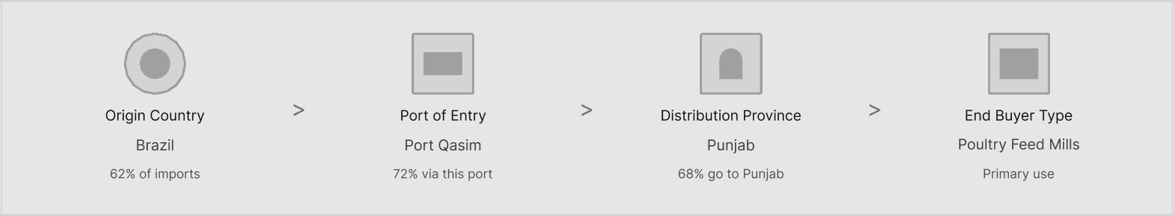

Top Provinces by Volume Top Ports by Volume

|  |  |  |  |
| --- | --- | --- | --- |
|  | 68% |  | 72% |
| Sindh | 25% |  |  |
|  | 7% |  | 3% |



°^ Volume up 18% YoY | w Avg price down 5B since Jan 2025 v 12 new buyers added in Q3 2025

Soybean Oil PamOil

Data source d from PAR TradeLens | Coverage: Pakist an-only trade data | Jan 202 2 - Sep 2025 | Last updated: Nov 12, 2025

 

About



Legal

Terms

PAR Partnership

Trade Network ° Fahad Nadeem Sign out

Soybean Import (Jan 22 — Sep 25)

Overview Summary Comparison Details Global View

|  |  |  |  |  |
| --- | --- | --- | --- | --- |
| 1.2M | $485  Avg Price (USD/MT) | 342  Total Buyers | 128 | 15 |

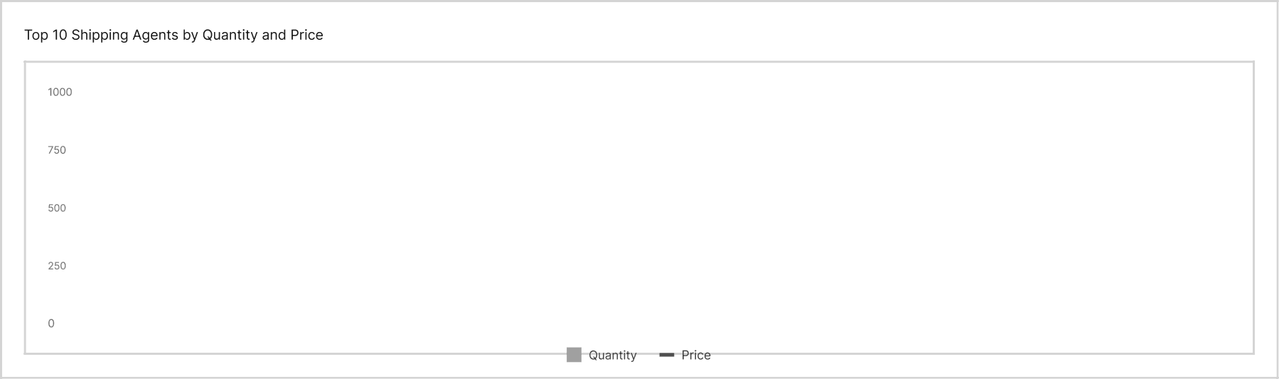



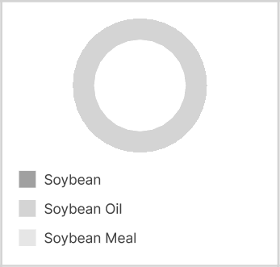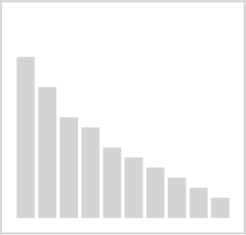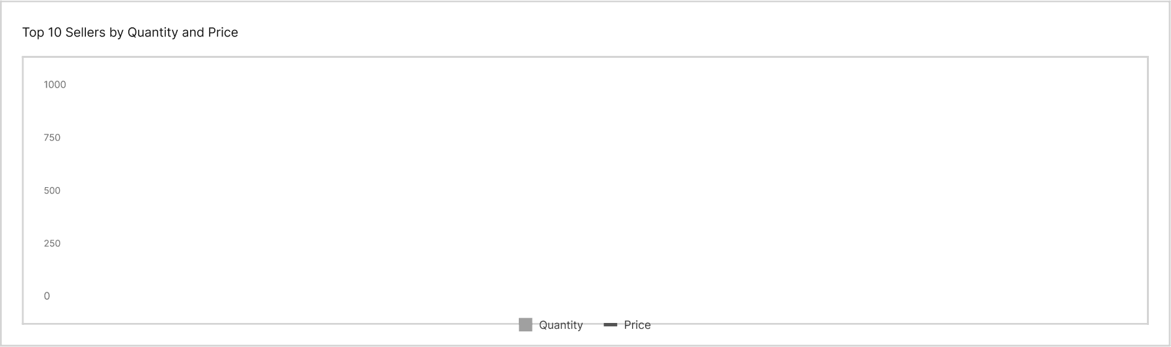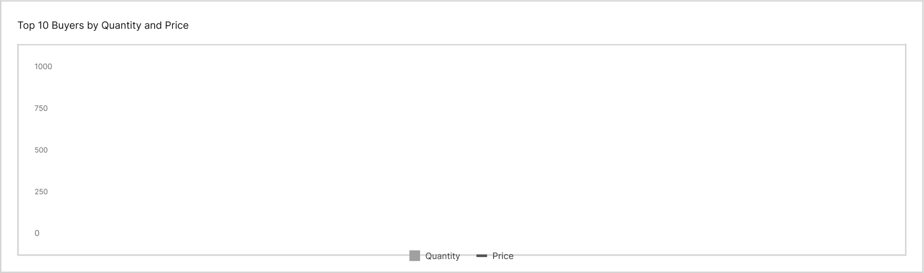

0 Reset

All Years

All Months

All Sellers

Countries

All Countries

All Products

Top 10 Countries by Gluantity

  



PAR Partnership

Social

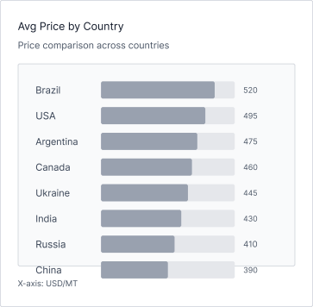

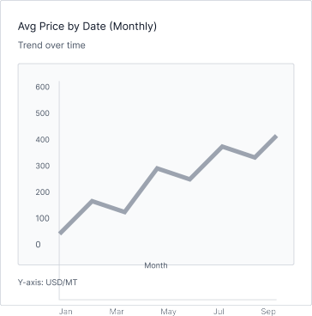

Trade Network ¥

Soybean Import (Jan 22 — Sep 25)

FN Fahad Nadeem Si O

    







Select Year



Select Sellers

Buyer







18,350

 

oct



 







Soybean 328,391

”j}"”“’ 142,580

p}” ’ 89,450 425



BennEporslx Benn





House

Ukraine Grain



9,800

8,900

538

612

Jul

Jun

May 



2024



Feb

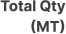 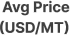



Canada J9,672

612



eaxisian'spemerjri=iard



About



Legai



PAR Partnership

some trade Neiwortv

Soybean Import (Jan 22 — Sep 25)

One new Summa y comparison Details Glooalvew

rw FahadNadeem Gg O



Year

Select Year



Select Buyers



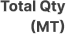Select Sellers

’"“ 1.66M



Global Trade Distribution

613

233

Total Buyers



509 24

Total Sellers





4.7J& 5J8

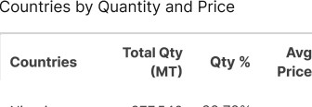





PAR Partnership

**Trade Network - Find Suppliers**

13

Fahad Nadeem

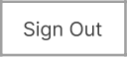

Sign Out

Find Suppliers

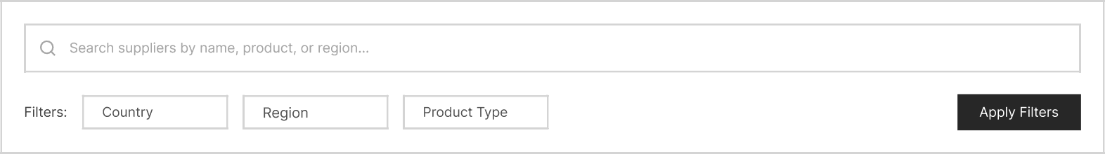

Recommended Suppliers

top suppliers marching your business pro{le

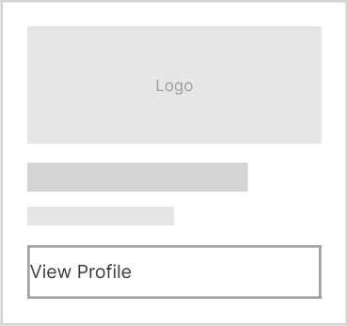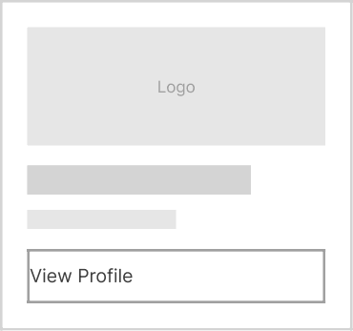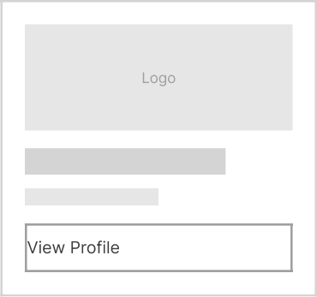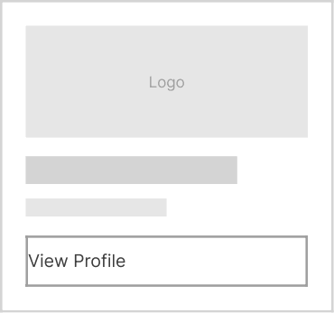

All Suppliers

Browse all verified suppliers in our network

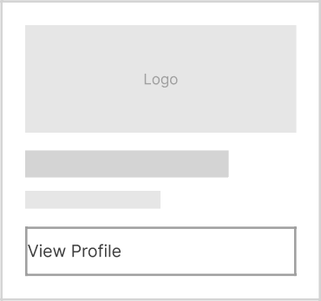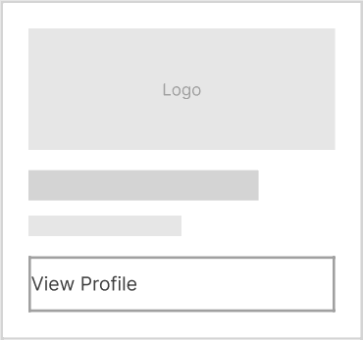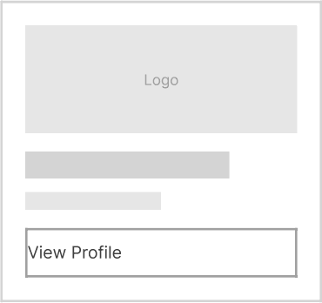



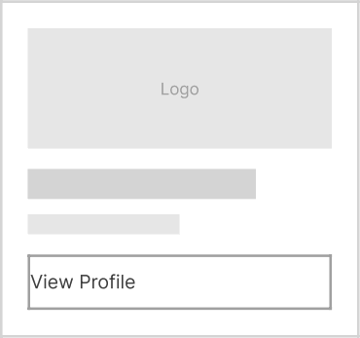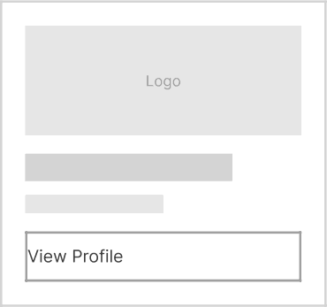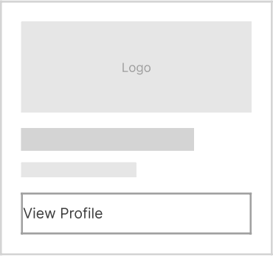

10 Next

COM 9Hng

About



O 2024 Zaralink. All rights reserved

Showing 1,234 suppliers

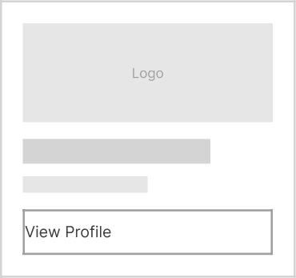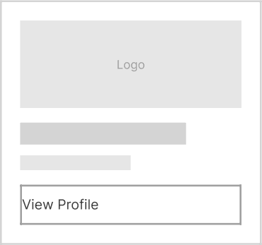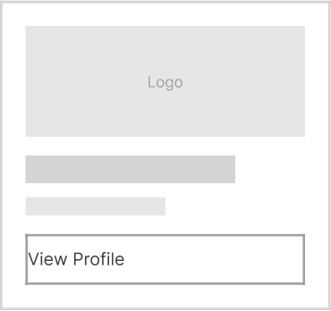

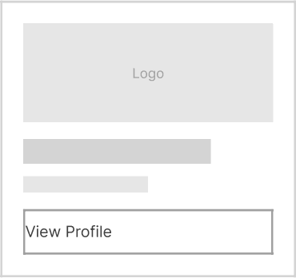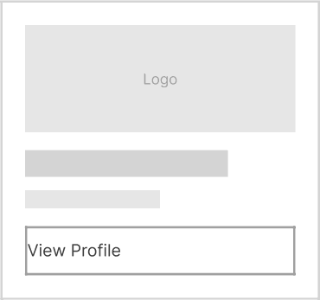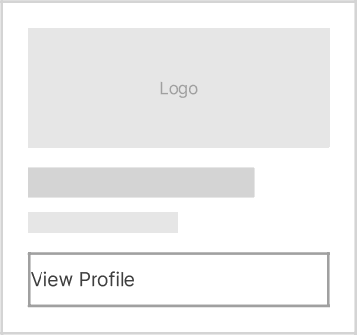Legal Terms

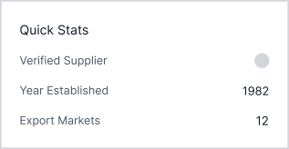

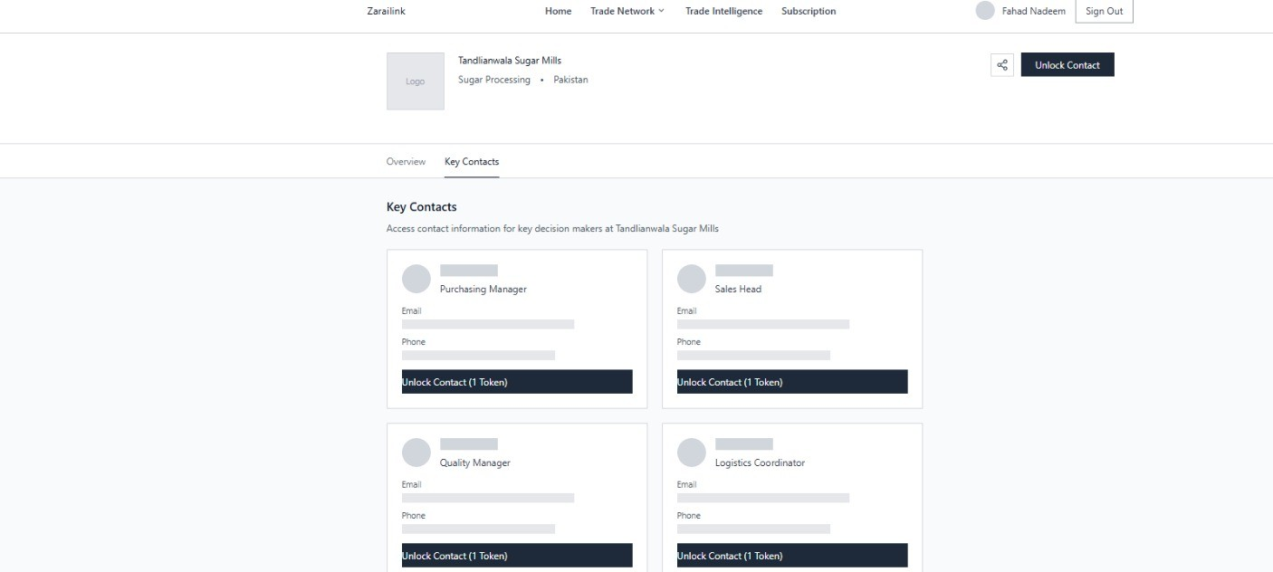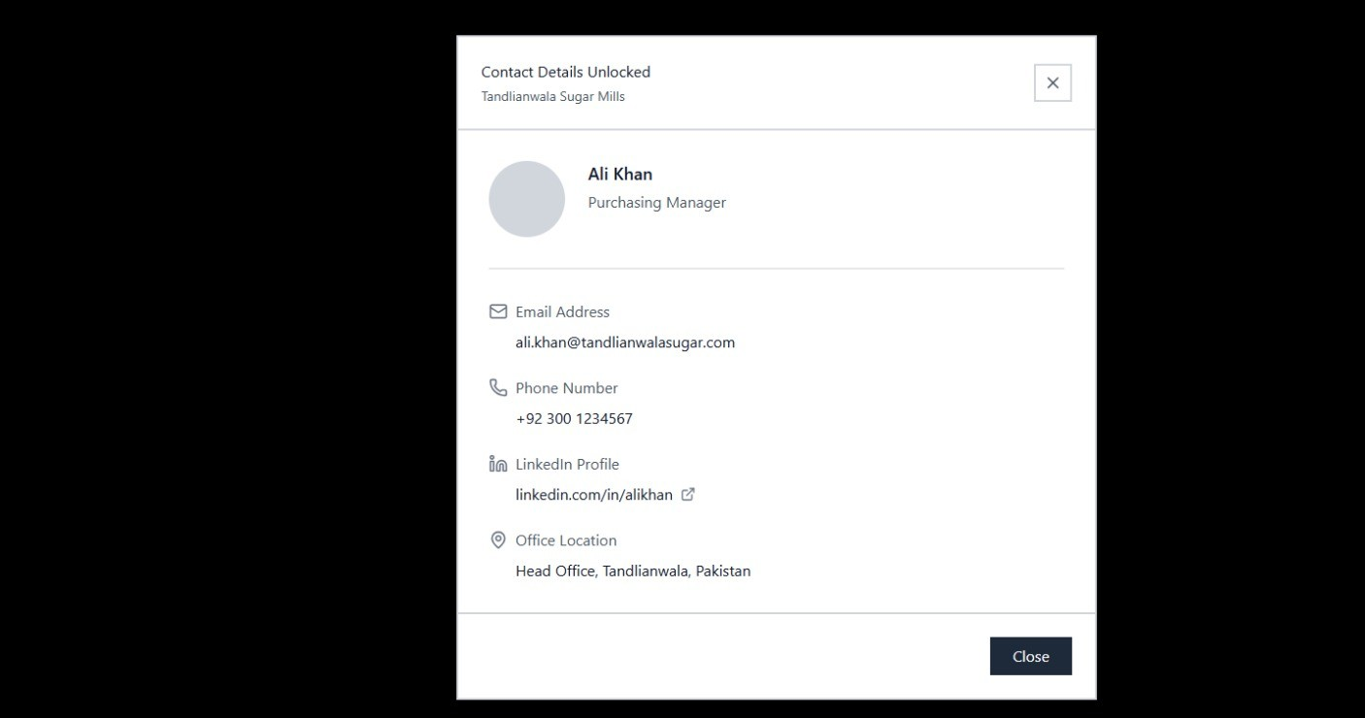

**Trade Network - Find Buyers**

Home TradeNetwork •

Fahad Nadeem



Sign Out

Find Buyers

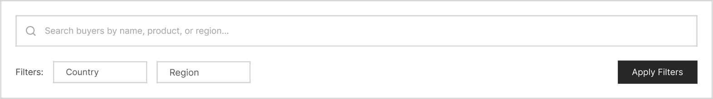

Recommended Buyers



All Buyers

Showing 89 2 buyers

Browse all verified buyers in our network



Previous 2 3 8 Next

 

About



Legal Terms

PAR Partnership

é 2024 Zaralink. Al rights reserved

Home Trade Network •   % Fahad Nadeem SEO

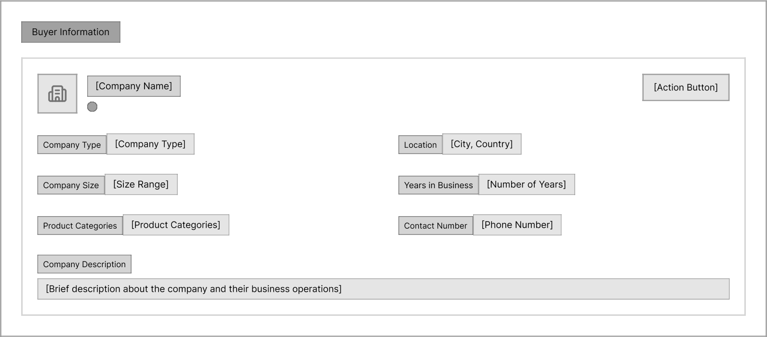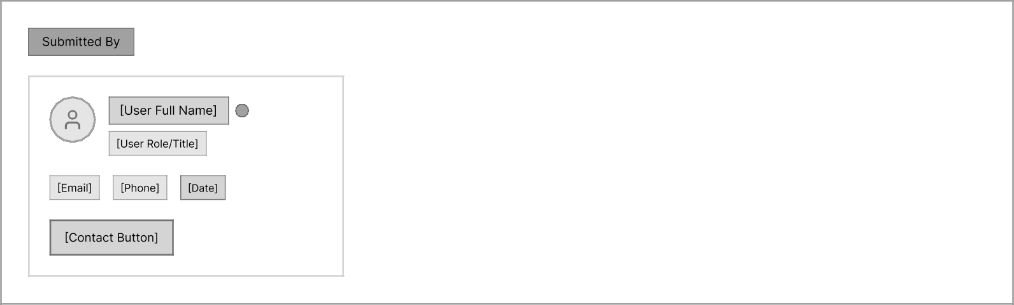

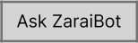

**Trade Alert & Pulse**

20

 Trade Network Y   FN Fahad Nadeem



Sign Out



Trending Topics



Wheat exports to UAE increase by 22% in Q4



Rice price volatility detected in Sindh region



New trade agreement impacts cotton imports

Recent Alerts



Soybean imports up 15% MoM



Mango harvest season begins early in Punjab



Dairy product demand surges in urban centers

Your Followed Products

ates on products you're tracking



Corn futures show positive momentum for Q1 2025



Citrus export opportunities expand to new markets

About Terms



PAR Partnership

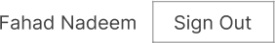 Trade Network Y Trade Intelligence Subscription FN

Soybean import prices surged 20% in September

 • Sept 20, 2024

soybean erazii Price Poiicy

Summary

Why it matters

Market Impact Analysis

Data Snapshot

Price trend* and market indicators

Related Dashboards



Market Brief Summary Soybean trade Anaiysis

Actions

Save







About

Share





Terms

Home Trade Networky Trade Intelligence Subscription 8^* Fahad Nadeem Sig 0 t

My Trade Pulse Preferences



Saved Analyses Followed Topics



vewa dmanageyo rsavedmatewnsgh‹sandreporis

Soybean import prices surged 20% in September



Wheat exports to UAE increase by 22% in Q4

Saved on Sept 18, 2024

Rice price volatility detected in Sindh region

Saved on Sept 15, 2024

New trade agreement impacts cotton imports

Saved on Sept 12, 2024

Corn futures show positive momentum for Q1 2025

saved on sept 1o, zoz4

Zarailink

About Terms

PAR Partnership

o zo24 zaraiiink. Aii rignts reserved.

**TradeLedger**

24

 Trade Network



Trade Ledger

Company activity based on Pakistan customs data (Jan 2022 — Sep 2025)

Search companies (e.g., M.A Oils)



|  |  |  |  |  |  |
| --- | --- | --- | --- | --- | --- |
| Q | Company Name | TotaVolume(MT1 |  | Active | banners |
| @ | M.A Oils Pvt Ltd | 1,200,000 | 550 | 24 | A +18% |
| 0 | Green Valley Traders | 850,000 | 485 | 18 | A +12% |
| I**l | Punjab Agro Industries | 720,000 | 620 | 31 | V -5% |
|  |  | 650,000 | 510 | 22 | A +25% |
|  |  | 580,000 | 475 | 16 | 1 +8% |
| @ | National Commodities Ltd | 520,000 |  | 28 | V -3% |
| D | Lahore Mills Corporanon | 490,000 | 530 | 20 |  |
| 0 | Pakistan Grain Exporters | 445,000 | 55 5 | zs | *+22% |
| 0 | Balochistan Trade Partners | 380,000 | 460 | 14 | T-8% |
| CJ | lsamabad lmportExpor| | 325,000 | 580 | 19 | 1 *10% |

About

 Terms PARPartnershp



•Revenue estimates = onantity • Avg Price from customs data. Not audited financiais.‘

 Trade Network



M.A Oils Pvt Ltd

Based on 142 verified transactions (Jan 2o22 — sep 2o2sj





$6.27M

1.2M

24

*18%

Top 3 Traded Products Soybean — 78% of volume

Soybean Meal — 15% of volume Soybean Oil — 7% of volume

Top Importing Countries

Pakistan — 87% gqpgpąqyg _ gą

Afghanistan — 4%

Top Exporting Countries

Brazil — 62%

USA — 25%

Argentina — 13%

Recent Activity

A18% volume YoY | V5% avg price since Jan 2025 | 12 new partners in Q3 2025

About  Terms PARPartnershp



M.A Oils Pvt Ltd

Based on 142 verified transactions (Jan 2022 — Sep 2025)





|  |
| --- |
| YoY Change % |
| 936,000 550 * +12%  Soybean Meal 180,000 48 5 *+8% |
|  |
| Soybean Oil 84,000 1,120 V -3% |
|  |
| Palm Oil 62,000 890 A +15% |
|  |
| Sunflower Oil 45,000 1,050 1 +6% |
|  |
| 38,000 620 V -5%  Canola Oil 2B,0O0 P80 A *22% |
|  |
| Con 22,000 280 7-2% |

|  |  |
| --- | --- |
| Soybean | 78% |
| Soybean Meal | 15% |
| M Soybean Oil | 7% |

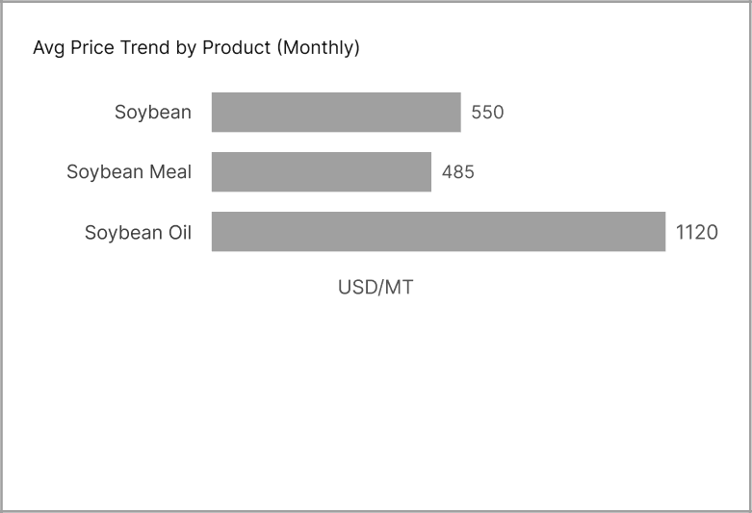About Contact Terms PAR Partnership

Home Trade Network Trade Intelligence Subscription

M.A Oils Pvt Ltd

Based on 142 verified transactions (Jan 2022 — Sep 2025)

Overview Products Partners Trends



|  |
| --- |
| Partner Diversity Score  0.72  Based on voiume distribution across partners |



Brazil

Ukraine



USA — 25% of total volume

'Now:Noé,erfse|er,«mes—on, on", ggregwes

Top Ports of Entry

Port Qasim —78Aâ of shipments Karachi Port — 15% of shipments Gwadar Port —7% of shipments

About

  PAR Partnership



'Revenue estimated from customs declarations (Quantity x Avg Price). Not audited.'





Compare Companies

Based on Pakistan customs data IJan 2022— Sep 2025)

Home Trade Network Trade Intelligence Subscription



Selected Companies (3): s Fas i



M.A Oils X

|  |  |  |  |  |  |  |
| --- | --- | --- | --- | --- | --- | --- |
| VolumeGrowth(YoY) |  | Price Volatility (o) |  | Top Source Country |  |  |
| A18% |  | M.A Oils:  0.15 |  |  |  | 0.72 |
| Acis Agro:  *12% |  | 0.22 |  |  |  | Acis Agro:  0.65 |
| T3% |  | 0.08 |  |  |  | Ghani Foods:  0.81 |

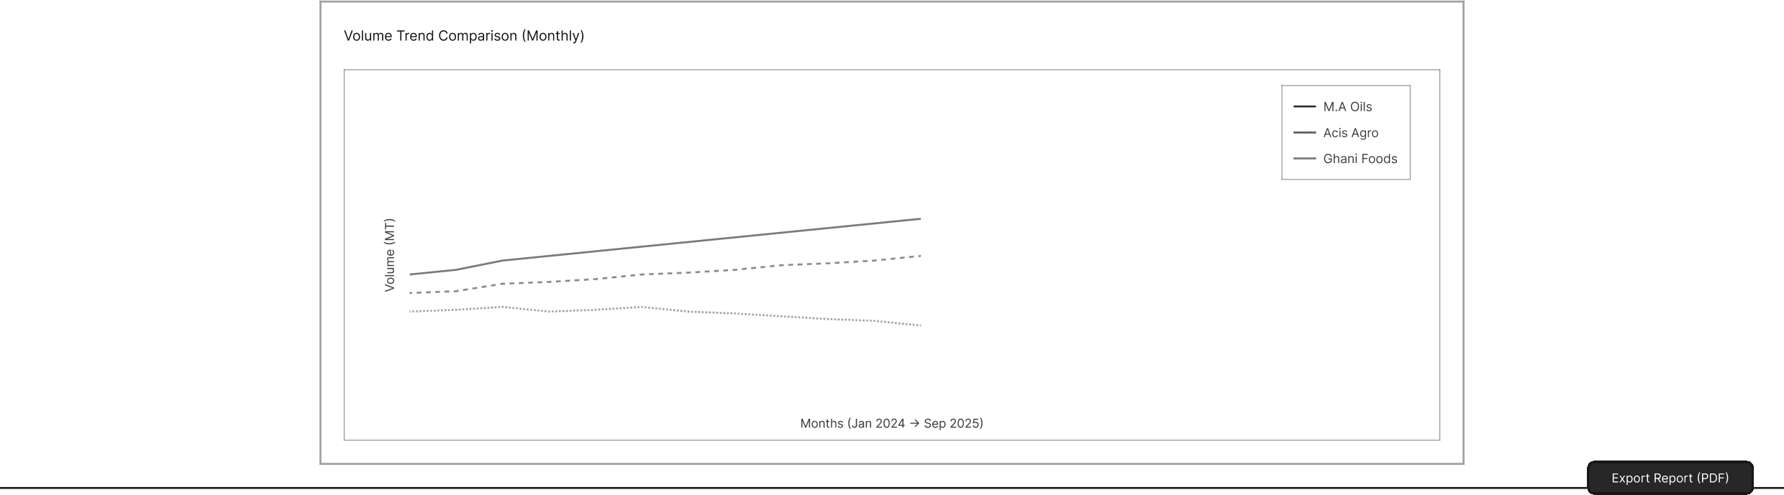About 

PAR Partnership



•Revenue estimated from customs deciarations louantity x avg Priced. Not audited.•

’All metrics calculated from system transaction data. No user-uploaded benchmarks.’

**Subscriptions**

31



    



